Product Inventory Management System
Backend Project Documentation
Team ID: SWTID-2026-3105
Team Leader: Reshma D
Email: reshmalathi144@gmail.com
Team Members:
- Akshaya P – akshayaachu065@gmail.com
- Sivaranjini M – ranjaniranjani1808@gmail.com
- Kiruthiga S – kiruthigakeerthi02@gmail.com
ABSTRACT:
- The Product Inventory Management System is a backend application developed using Node.js, Express.js, and MongoDB.
- The main purpose of this system is to manage product inventory in an efficient and secure way.
- The system allows users to register and log in securely.
- After authentication, users can perform operations such as adding products, viewing product details, updating product information, and deleting products.
- All the data is stored securely in the MongoDB database.
- Passwords are encrypted using bcryptjs and authentication is handled using JSON Web Tokens (JWT).
- This project demonstrates how modern backend technologies can be used to build a secure and scalable inventory management system.
INTRODUCTION:
- Inventory management is an important part of any business. It helps businesses track products, manage stock levels, and organize product information effectively.
- Manual inventory management can be time-consuming and may lead to errors.
- To solve this problem, the Product Inventory Management System was developed.
- This system allows users to manage product data digitally through secure backend APIs.
- The system enables users to store product information such as product name, price, quantity, and description. Using technologies such as Node.js, Express.js, and MongoDB, the system provides fast and reliable backend services.

OBJECTIVES:
The main objectives of the Product Inventory Management System are:
- To develop a backend system for efficient product inventory management.
- To implement secure user authentication using JSON Web Token (JWT).
- To allow users to manage their own product information securely.
- To perform CRUD (Create, Read, Update, Delete) operations on product data.
- To store and manage product details securely in the MongoDB database.
- To provide secure and reliable API endpoints for accessing and managing product data.
TECHNOLOGIES USED:
1.Node.js:-
Node.js is used as the runtime environment for running the backend server.
2.Express.js:-
Express.js is a web framework used to create REST APIs and handle HTTP requests.
3.MongoDB:-
MongoDB is a NoSQL database used to store user and product data.
4.Mongoose:-
Mongoose is used to connect Node.js applications with MongoDB.
5.JSON Web Token (JWT):-
JWT is used for secure authentication and authorization.
6.Bcryptjs:-
Bcryptjs is used for encrypting user passwords before storing them in the database.
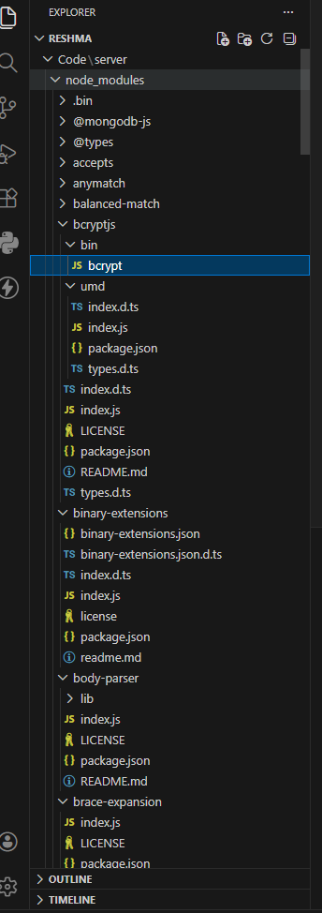
SYSTEM ARCHITECTURE:
The system follows a three-tier architecture.
Client Layer:-
This layer represents the users who interact with the system and send requests.
Backend Layer:-
The backend server processes user requests and performs operations such as authentication and product management.
Database Layer:-
The database layer stores user data and product information securely.
System Flow:-
User → Backend Server → Database → Response to User
DATABASE ARCHITECTURE:-
The system uses MongoDB as the database.
Users Collection:-
The users collection stores details about registered users.
- Fields include:
User ID
Name
      - Email
      - Password
      - Created Date
Passwords are stored in encrypted format for security.
Products Collection:-
The products collection stores information about products.
Fields include:
• Product ID
• User ID
• Product Name
• Price
• Quantity
• Description
• Created Date
Relationship:
One User → Many Products
This means a single user can create and manage multiple products.
CORE FEATURES:
The system provides the following features:
User Registration:
- Users can create a new account in the system.
User Login:
- Registered users can log in using their credentials.
Add Product:
- Users can add new products to their inventory.
View Products:
- Users can view the list of products they created.
Update Product:
- Users can update product details such as price or quantity.

Delete Product:
- Users can remove products from their inventory.

Product Search:
- Users can search products by name.
Secure API Access:
- All APIs are protected using authentication middleware.
API TESTING:-
- The APIs were tested using Thunder Client in Visual Studio Code.
The following APIs were tested:
Register User API:
- Allows new users to create an account.
Login User API:
- Allows registered users to log in and receive a JWT token.
Create Product API:
- Allows users to add new products to their inventory.
Get Products API:
- Returns the list of products created by the user.
Update Product APICORE FEATURES:
The system provides the following features:
User Registration:
- Users can create a new account in the system.
User Login:
- Registered users can log in using their credentials.
Add Product:
- Users can add new products to their inventory.
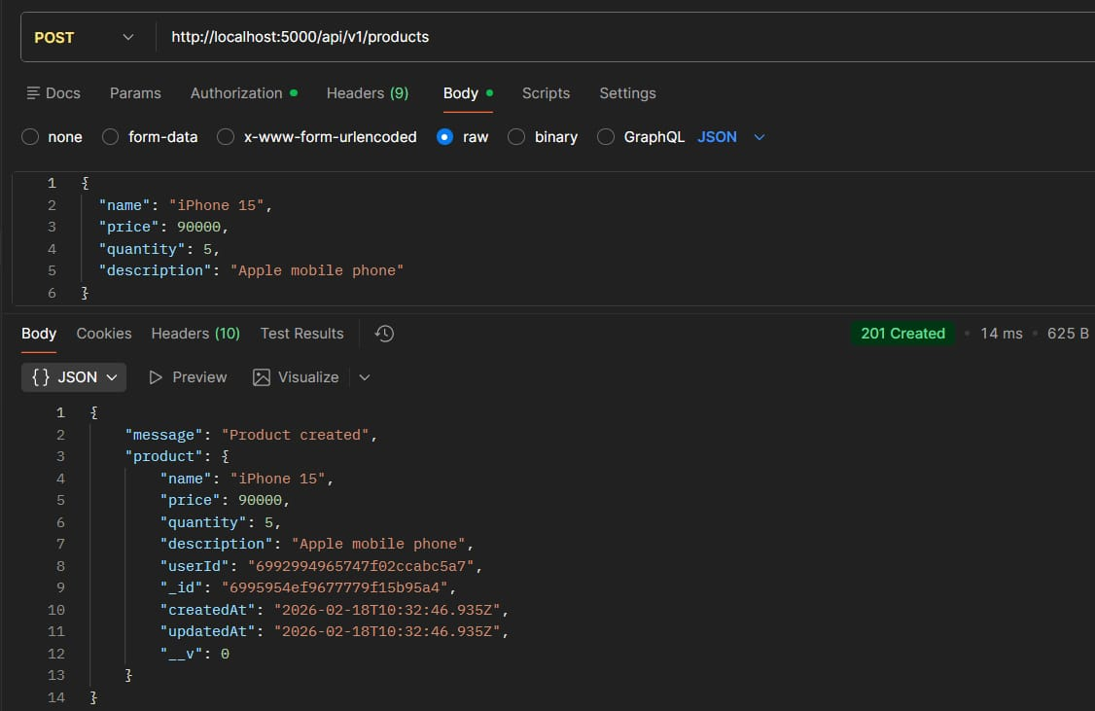

View Products:
- Users can view the list of products they created.
Update Product:
- Users can update product details such as price or quantity.
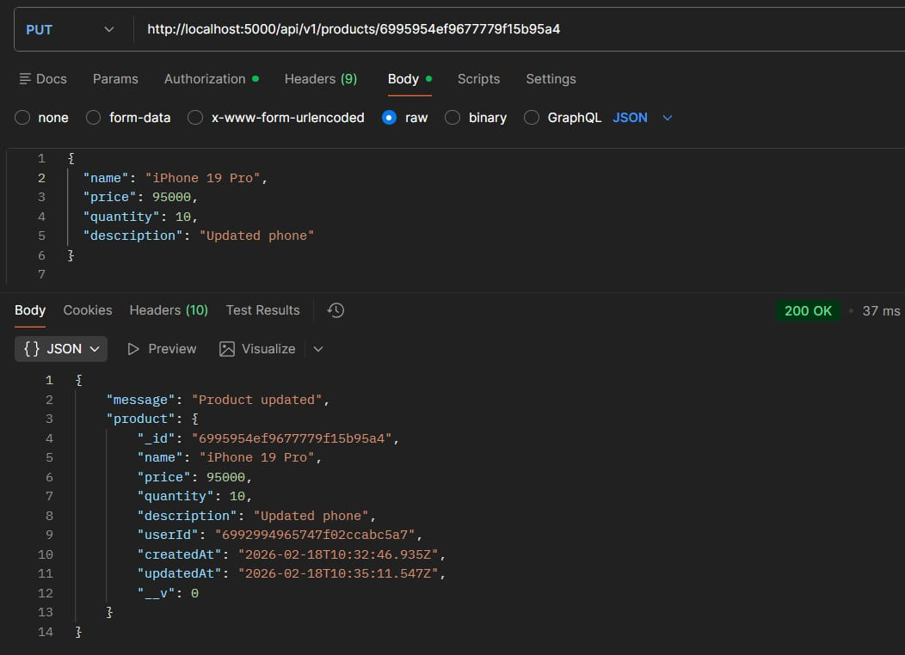

Delete Product:
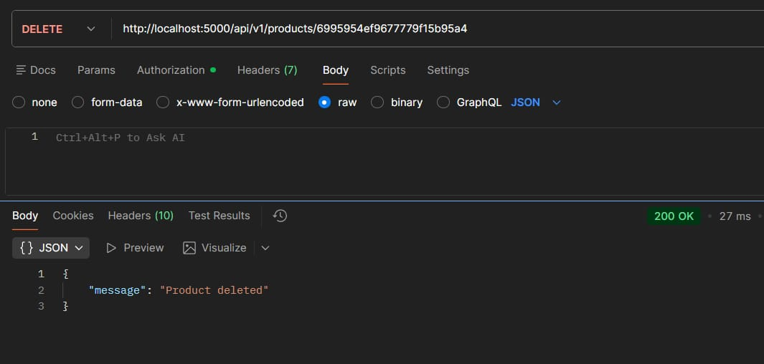
- Users can remove products from their inventory.

Product Search:
- Users can search products by name.

- Secure API Access:
All APIs are protected using authentication middleware.
- Allows users to update product information.
- Delete Product API
Allows users to delete products from the system.
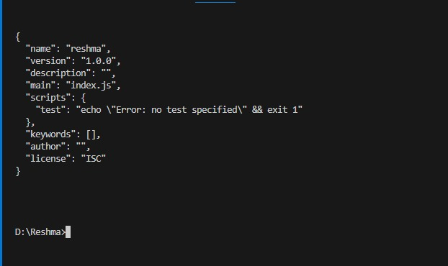

CONCLUSION:-
- The Product Inventory Management System provides a secure and efficient solution for managing product inventory.
- It allows users to register, log in, and perform operations such as adding, updating, viewing, and deleting products.
- Using modern backend technologies like Node.js, Express.js, and MongoDB, the system ensures fast performance and secure data management.
- This project also helps developers and students understand backend development and API creation.

